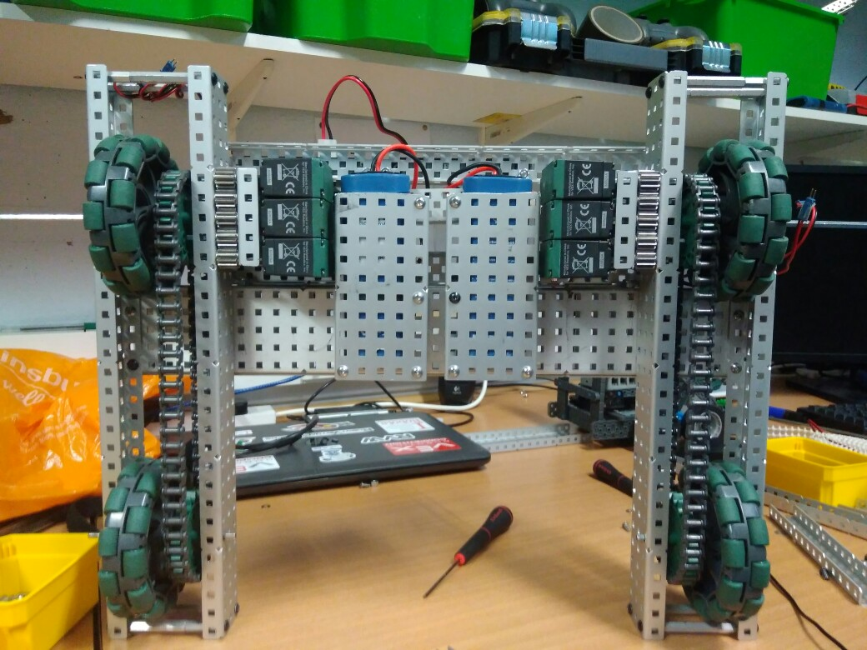

**Specification:**

* 6 Motor HS drive
* 2 drive chains
* 4 wheels
* Aluminium structure

**Dimensions:**

17.5” x 15”

**Changes Made:**

* Added 2 battery mounts
* Added the front mounting plate for the lift mechanism
* Securely mounted the brain and power extender
* Added a method to secure the batteries when the robot is active

**Future Changes:**

* Cable Management!
* Start work on the primary and secondary lift

Robot v1.1.2

**Overview:**

The next addition is a device for storing batteries. A large 10 x 5 C section is suspended by 3 stand-offs. The batteries can be easily slipped in and out then secured by tightening a securing bar. The batteries are then plugged into two cable extenders that are plugged in respectively to the cortex and the power extender. We have also added a large plate for the primary lift to be mounted upon. The cortex mounting has been replaced with a more reliable system and a power extender has been added. After everything is wired in the base will be fully functioning.

Logged by Felix Black

28/06/2017 – 17:12